NUAA

The Software Development Project Report

Chinese Chess

team member:

161510315 Fancy Yuchao Huang

161510321 GJ Ji Gao

161540118 Sheron Spring Chunxu Rao

161510318 Steven Jianing Ni

Catalogue

One. The demand analysis

Two. The main function of the program

Three. The operation platform of the program

Four. The main structure of the system

Five. The module analysis

Six. The explanation of the class

Seven. The benefit of the project

Eight. The parts that every member of team does

Nine. The appearance of the product

One. The demand analysis

In our daily life, Chinese chess is a very common activity. But it's not possible that we take along with Chinese chess everywhere. In order to making playing Chinese chess with each other convenient, we decide to do a java project about Chinese chess.

Two. The main function of the program

In this project, we can play Chinese chess with each other. And when we cannot find other one who can play Chinese chess, we can also play chess with the computer.

Three. The operation platform of the program

eclipse 4.5.2

Four. The main structure of the system

Main Menu

pve

(people vs AI)

pvp

(people vs people)

background

chessboard

Record of game

regret

give up

Five. The module analysis

1.pvp:

In this part, two people can play Chinese chess with each other. And if you are hopeless for the victory, you can choose the button "give up". You can choose "regret" to return to the last step. The left side of the interface is the record of game.

2.pve:

In this part, one person can play Chinese chess with the computer.

**Fancy gave every chess with a contribution**. If AI eat the chess belonging to player, **the value evaluation will add the contribution.** Also AI will trying to play the role of player, and if one possible step AI’s chess is eaten by the “player”, the value evaluation will minus the contribution of AI’s chess. **Thus, Fancy used DFS algorithm to calculating the max possible value for further 3 step**, **so AI will choose the step to try to get the most value, not just randomly chooses a chess and go to any position if valid.**

And we do so many tests to prove that the AI is clever enough, sometimes if you underestimate the power of AI, it will beat you, like one picture at the end of the document.

And if you think the computer is so clever that you are hopeless to overcome the computer, you can choose the button "admitting defeat" to try again.

Other parts including "regret", "chessboard", "record of game" are the same as “pvp” part.

Six. The explanation of the class

Package: AI

ArtificialIntelligence: show the intelligence of the computer in the PVP part.

PVPController: this part can judge if the move of the chess is available in the PVP part.

Package: GUI

Background:

Import the picture of the main menu background.

ChessPanel:

Import the picture the chess board

PlayerVSEnviroment: There is 90 buttons on the chess board, we can choose one chess and put on another button.

PlayerVSplayer:

It is the same as PlayerVSEnviroment, apart from that the black chess will move automatically.

TypeInterface:

This part will show the interface of the game record, and the two important buttons, "regret", "give up".

Package: Rule

ChineseJudge:

When the start place and end place of one chess is confirmed, this class can judge if it is available.

NextStep:

When you choose a chess on the chessboard, this class will tell you everywhere the chess can get. this part is related with AI because the computer should know where a chess can get.

Seven. The benefit of the project

By doing this project, we have a deeper understanding of some part of the Java programming, such as loop, class, inherit, polymorphism, GUI, GY. We have realized that Java is a very important and efficient program language, which can solve many problems about computer. And it's very important to make program operating efficiently.

And by following the step to learn how to create an AI, we all try brand new thing, it’s extremely interesting, and thus prove that we all have the ability to challenge, and develop an complex project.

Eight. The parts that every member of team does

161510315 Fancy: package AI

161510321 GJ: package Rule

161540118 Sheron Spring: package GUI

161510318 Steven: writing the report. I have tried my best to do the networking which can make us play chess online, but failed. I think it's too difficult for me.

Nine. The appearance of the product

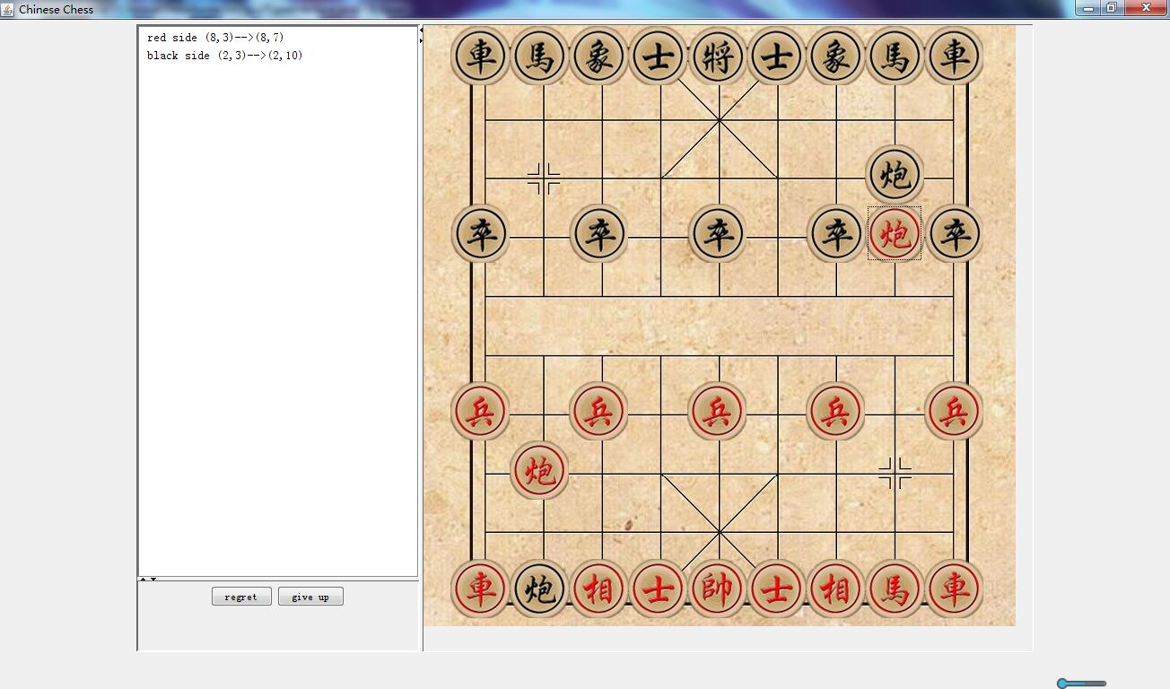

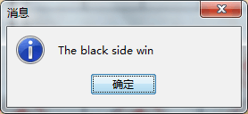

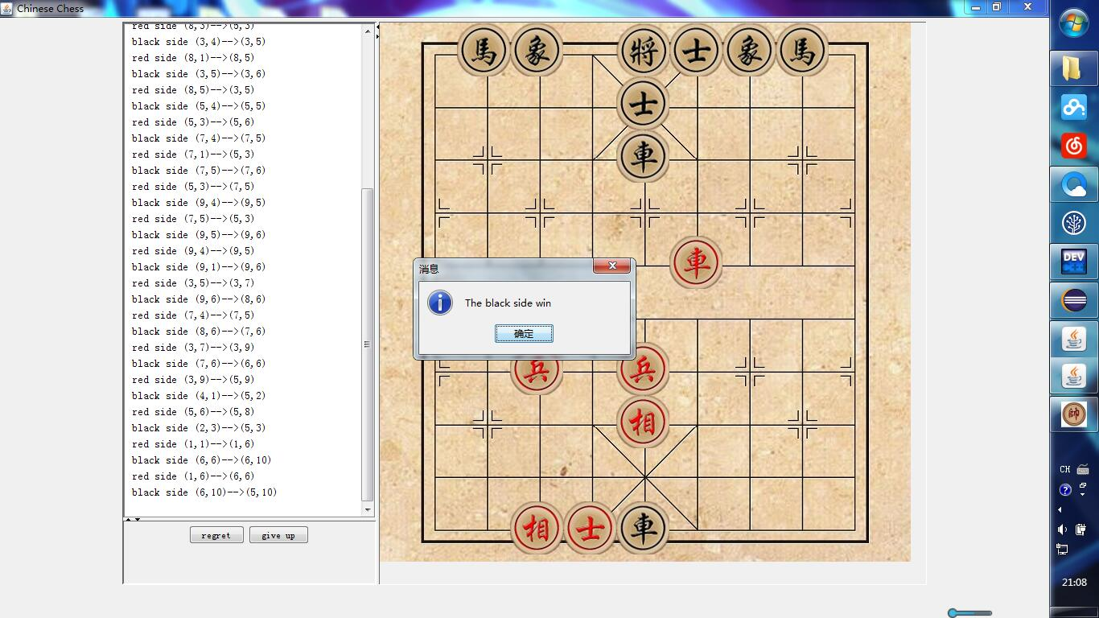

//this is about AI, black side is AI, so amazing.